Name : Kumari Pooja | Date : 13/12/2018
Assignment 2 Django Polls Application | USN No. : 01FM17MCA405
------------------------------------------------------------------------------------------------------------------------
pooja@pooja-HP-Pavilion-g6-Notebook-PC:~$ sudo apt update
[sudo] password for pooja:
Hit:1 http://in.archive.ubuntu.com/ubuntu bionic InRelease
Get:2 http://security.ubuntu.com/ubuntu bionic-security InRelease [83.2 kB]
Get:3 http://in.archive.ubuntu.com/ubuntu bionic-updates InRelease [88.7 kB]
Get:4 http://in.archive.ubuntu.com/ubuntu bionic-backports InRelease [74.6 kB]
Get:5 http://security.ubuntu.com/ubuntu bionic-security/main amd64 Packages [221 kB]
Get:6 http://in.archive.ubuntu.com/ubuntu bionic-updates/main i386 Packages [402 kB]
Get:7 http://security.ubuntu.com/ubuntu bionic-security/main i386 Packages [171 kB]
Get:8 http://security.ubuntu.com/ubuntu bionic-security/main Translation-en [85.0 kB]
Get:9 http://in.archive.ubuntu.com/ubuntu bionic-updates/main amd64 Packages [459 kB]
Get:10 http://security.ubuntu.com/ubuntu bionic-security/main amd64 DEP-11 Metadata [204 B]
Get:11 http://security.ubuntu.com/ubuntu bionic-security/universe amd64 Packages [107 kB]
Get:12 http://in.archive.ubuntu.com/ubuntu bionic-updates/main Translation-en [171 kB]
Get:13 http://security.ubuntu.com/ubuntu bionic-security/universe i386 Packages [106 kB]
Get:14 http://in.archive.ubuntu.com/ubuntu bionic-updates/main amd64 DEP-11 Metadata [245 kB]
Get:15 http://security.ubuntu.com/ubuntu bionic-security/universe Translation-en [61.0 kB]
Get:16 http://security.ubuntu.com/ubuntu bionic-security/universe amd64 DEP-11 Metadata [14.5 kB]
Get:17 http://in.archive.ubuntu.com/ubuntu bionic-updates/main DEP-11 48x48 Icons [55.7 kB]
Get:18 http://security.ubuntu.com/ubuntu bionic-security/universe DEP-11 48x48 Icons [9,088 B]
Get:19 http://in.archive.ubuntu.com/ubuntu bionic-updates/main DEP-11 64x64 Icons [105 kB]
Get:20 http://security.ubuntu.com/ubuntu bionic-security/universe DEP-11 64x64 Icons [36.7 kB]
Get:21 http://in.archive.ubuntu.com/ubuntu bionic-updates/restricted amd64 Packages [6,992 B]
Get:22 http://security.ubuntu.com/ubuntu bionic-security/multiverse amd64 Packages [1,440 B]
Get:23 http://in.archive.ubuntu.com/ubuntu bionic-updates/restricted i386 Packages [6,928 B]
Get:24 http://security.ubuntu.com/ubuntu bionic-security/multiverse i386 Packages [1,608 B]
Get:25 http://in.archive.ubuntu.com/ubuntu bionic-updates/universe i386 Packages [588 kB]
Get:26 http://in.archive.ubuntu.com/ubuntu bionic-updates/universe amd64 Packages [594 kB]
Get:27 http://in.archive.ubuntu.com/ubuntu bionic-updates/universe Translation-en [166 kB]
Get:28 http://in.archive.ubuntu.com/ubuntu bionic-updates/universe amd64 DEP-11 Metadata [199 kB]
Get:29 http://in.archive.ubuntu.com/ubuntu bionic-updates/universe DEP-11 48x48 Icons [186 kB]
Get:30 http://in.archive.ubuntu.com/ubuntu bionic-updates/universe DEP-11 64x64 Icons [333 kB]
Get:31 http://in.archive.ubuntu.com/ubuntu bionic-updates/multiverse i386 Packages [6,524 B]
Get:32 http://in.archive.ubuntu.com/ubuntu bionic-updates/multiverse amd64 Packages [6,372 B]
Get:33 http://in.archive.ubuntu.com/ubuntu bionic-updates/multiverse Translation-en [3,356 B]
Get:34 http://in.archive.ubuntu.com/ubuntu bionic-updates/multiverse amd64 DEP-11 Metadata [2,464 B]
Get:35 http://in.archive.ubuntu.com/ubuntu bionic-backports/universe i386 Packages [3,476 B]
Get:36 http://in.archive.ubuntu.com/ubuntu bionic-backports/universe amd64 Packages [3,468 B]
Get:37 http://in.archive.ubuntu.com/ubuntu bionic-backports/universe Translation-en [1,604 B]
Get:38 http://in.archive.ubuntu.com/ubuntu bionic-backports/universe amd64 DEP-11 Metadata [5,812 B]
Get:39 http://in.archive.ubuntu.com/ubuntu bionic-backports/universe DEP-11 64x64 Icons [29 B]
Fetched 4,611 kB in 39s (117 kB/s)
Reading package lists... Done
Building dependency tree
Reading state information... Done
179 packages can be upgraded. Run 'apt list --upgradable' to see them.
pooja@pooja-HP-Pavilion-g6-Notebook-PC:~$ sudo apt install python3-pip
Reading package lists... Done
Building dependency tree
Reading state information... Done
The following packages were automatically installed and are no longer required:
python-apt python-pycurl
Use 'sudo apt autoremove' to remove them.
The following additional packages will be installed:
libpython3-dev libpython3-stdlib libpython3.6 libpython3.6-dev
libpython3.6-minimal libpython3.6-stdlib python3 python3-dev
python3-distutils python3-minimal python3-setuptools python3-wheel python3.6
python3.6-dev python3.6-minimal
Suggested packages:
python3-doc python3-tk python3-venv python-setuptools-doc python3.6-venv
python3.6-doc binfmt-support
The following NEW packages will be installed:
libpython3-dev libpython3.6-dev python3-dev python3-pip python3-setuptools
python3-wheel python3.6-dev
The following packages will be upgraded:
libpython3-stdlib libpython3.6 libpython3.6-minimal libpython3.6-stdlib
python3 python3-distutils python3-minimal python3.6 python3.6-minimal
9 upgraded, 7 newly installed, 0 to remove and 170 not upgraded.
Need to get 51.0 MB/51.4 MB of archives.
After this operation, 78.7 MB of additional disk space will be used.
Do you want to continue? [Y/n] y
Get:1 http://in.archive.ubuntu.com/ubuntu bionic-updates/main amd64 python3.6 amd64 3.6.7-1~18.04 [197 kB]
Get:2 http://in.archive.ubuntu.com/ubuntu bionic-updates/main amd64 libpython3.6 amd64 3.6.7-1~18.04 [1,415 kB]
Get:3 http://in.archive.ubuntu.com/ubuntu bionic-updates/main amd64 libpython3.6-stdlib amd64 3.6.7-1~18.04 [1,711 kB]
Get:4 http://in.archive.ubuntu.com/ubuntu bionic-updates/main amd64 python3-distutils all 3.6.7-1~18.04 [141 kB]
Get:5 http://in.archive.ubuntu.com/ubuntu bionic-updates/main amd64 python3.6-minimal amd64 3.6.7-1~18.04 [1,604 kB]
Get:6 http://in.archive.ubuntu.com/ubuntu bionic-updates/main amd64 libpython3.6-minimal amd64 3.6.7-1~18.04 [531 kB]
Get:7 http://in.archive.ubuntu.com/ubuntu bionic-updates/main amd64 python3-minimal amd64 3.6.7-1~18.04 [23.7 kB]
Get:8 http://in.archive.ubuntu.com/ubuntu bionic-updates/main amd64 python3 amd64 3.6.7-1~18.04 [47.2 kB]
Get:9 http://in.archive.ubuntu.com/ubuntu bionic-updates/main amd64 libpython3-stdlib amd64 3.6.7-1~18.04 [7,240 B]
Get:10 http://in.archive.ubuntu.com/ubuntu bionic-updates/main amd64 libpython3.6-dev amd64 3.6.7-1~18.04 [44.8 MB]
Err:10 http://in.archive.ubuntu.com/ubuntu bionic-updates/main amd64 libpython3.6-dev amd64 3.6.7-1~18.04
Undetermined Error [IP: 91.189.88.162 80]
Get:11 http://in.archive.ubuntu.com/ubuntu bionic-updates/main amd64 libpython3-dev amd64 3.6.7-1~18.04 [7,328 B]
Get:12 http://in.archive.ubuntu.com/ubuntu bionic-updates/main amd64 python3.6-dev amd64 3.6.7-1~18.04 [508 kB]
Get:13 http://in.archive.ubuntu.com/ubuntu bionic-updates/main amd64 python3-dev amd64 3.6.7-1~18.04 [1,288 B]
Fetched 6,193 kB in 3min 17s (31.4 kB/s)
E: Failed to fetch http://in.archive.ubuntu.com/ubuntu/pool/main/p/python3.6/libpython3.6-dev_3.6.7-1~18.04_amd64.deb Undetermined Error [IP: 91.189.88.162 80]
E: Unable to fetch some archives, maybe run apt-get update or try with --fix-missing?
pooja@pooja-HP-Pavilion-g6-Notebook-PC:~$ pip3 --version

Command 'pip3' not found, but can be installed with:

sudo apt install python3-pip

pooja@pooja-HP-Pavilion-g6-Notebook-PC:~$ sudo apt install python3-pip
Reading package lists... Done
Building dependency tree
Reading state information... Done
The following packages were automatically installed and are no longer required:
python-apt python-pycurl
Use 'sudo apt autoremove' to remove them.
The following additional packages will be installed:
libpython3-dev libpython3-stdlib libpython3.6 libpython3.6-dev libpython3.6-minimal libpython3.6-stdlib python3 python3-dev
python3-distutils python3-minimal python3-setuptools python3-wheel python3.6 python3.6-dev python3.6-minimal
Suggested packages:
python3-doc python3-tk python3-venv python-setuptools-doc python3.6-venv python3.6-doc binfmt-support
The following NEW packages will be installed:
libpython3-dev libpython3.6-dev python3-dev python3-pip python3-setuptools python3-wheel python3.6-dev
The following packages will be upgraded:
libpython3-stdlib libpython3.6 libpython3.6-minimal libpython3.6-stdlib python3 python3-distutils python3-minimal python3.6
python3.6-minimal
9 upgraded, 7 newly installed, 0 to remove and 170 not upgraded.
Need to get 44.8 MB/51.4 MB of archives.
After this operation, 78.7 MB of additional disk space will be used.
Do you want to continue? [Y/n] y
Get:1 http://in.archive.ubuntu.com/ubuntu bionic-updates/main amd64 libpython3.6-dev amd64 3.6.7-1~18.04 [44.8 MB]
Fetched 44.8 MB in 2min 42s (276 kB/s)
(Reading database ... 138228 files and directories currently installed.)
Preparing to unpack .../0-python3.6_3.6.7-1~18.04_amd64.deb ...
Unpacking python3.6 (3.6.7-1~18.04) over (3.6.6-1~18.04) ...
Preparing to unpack .../1-libpython3.6_3.6.7-1~18.04_amd64.deb ...
Unpacking libpython3.6:amd64 (3.6.7-1~18.04) over (3.6.6-1~18.04) ...
Preparing to unpack .../2-libpython3.6-stdlib_3.6.7-1~18.04_amd64.deb ...
Unpacking libpython3.6-stdlib:amd64 (3.6.7-1~18.04) over (3.6.6-1~18.04) ...
Preparing to unpack .../3-python3-distutils_3.6.7-1~18.04_all.deb ...
Unpacking python3-distutils (3.6.7-1~18.04) over (3.6.5-3) ...
Preparing to unpack .../4-python3.6-minimal_3.6.7-1~18.04_amd64.deb ...
Unpacking python3.6-minimal (3.6.7-1~18.04) over (3.6.6-1~18.04) ...
Preparing to unpack .../5-libpython3.6-minimal_3.6.7-1~18.04_amd64.deb ...
Unpacking libpython3.6-minimal:amd64 (3.6.7-1~18.04) over (3.6.6-1~18.04) ...
Setting up libpython3.6-minimal:amd64 (3.6.7-1~18.04) ...
Setting up python3.6-minimal (3.6.7-1~18.04) ...
(Reading database ... 138230 files and directories currently installed.)
Preparing to unpack .../python3-minimal_3.6.7-1~18.04_amd64.deb ...
Unpacking python3-minimal (3.6.7-1~18.04) over (3.6.5-3ubuntu1) ...
Setting up python3-minimal (3.6.7-1~18.04) ...
(Reading database ... 138230 files and directories currently installed.)
Preparing to unpack .../0-python3_3.6.7-1~18.04_amd64.deb ...
running python pre-rtupdate hooks for python3.6...
Unpacking python3 (3.6.7-1~18.04) over (3.6.5-3ubuntu1) ...
Preparing to unpack .../1-libpython3-stdlib_3.6.7-1~18.04_amd64.deb ...
Unpacking libpython3-stdlib:amd64 (3.6.7-1~18.04) over (3.6.5-3ubuntu1) ...
Selecting previously unselected package libpython3.6-dev:amd64.
Preparing to unpack .../2-libpython3.6-dev_3.6.7-1~18.04_amd64.deb ...
Unpacking libpython3.6-dev:amd64 (3.6.7-1~18.04) ...
Selecting previously unselected package libpython3-dev:amd64.
Preparing to unpack .../3-libpython3-dev_3.6.7-1~18.04_amd64.deb ...
Unpacking libpython3-dev:amd64 (3.6.7-1~18.04) ...
Selecting previously unselected package python3.6-dev.
Preparing to unpack .../4-python3.6-dev_3.6.7-1~18.04_amd64.deb ...
Unpacking python3.6-dev (3.6.7-1~18.04) ...
Selecting previously unselected package python3-dev.
Preparing to unpack .../5-python3-dev_3.6.7-1~18.04_amd64.deb ...
Unpacking python3-dev (3.6.7-1~18.04) ...
Selecting previously unselected package python3-pip.
Preparing to unpack .../6-python3-pip_9.0.1-2.3~ubuntu1_all.deb ...
Unpacking python3-pip (9.0.1-2.3~ubuntu1) ...
Selecting previously unselected package python3-setuptools.
Preparing to unpack .../7-python3-setuptools_39.0.1-2_all.deb ...
Unpacking python3-setuptools (39.0.1-2) ...
Selecting previously unselected package python3-wheel.
Preparing to unpack .../8-python3-wheel_0.30.0-0.2_all.deb ...
Unpacking python3-wheel (0.30.0-0.2) ...
Setting up libpython3.6-stdlib:amd64 (3.6.7-1~18.04) ...
Setting up python3.6 (3.6.7-1~18.04) ...
Processing triggers for mime-support (3.60ubuntu1) ...
Processing triggers for desktop-file-utils (0.23-1ubuntu3.18.04.1) ...
Processing triggers for bamfdaemon (0.5.3+18.04.20180207.2-0ubuntu1) ...
Rebuilding /usr/share/applications/bamf-2.index...
Processing triggers for libc-bin (2.27-3ubuntu1) ...
Processing triggers for man-db (2.8.3-2ubuntu0.1) ...
Setting up libpython3.6:amd64 (3.6.7-1~18.04) ...
Setting up libpython3-stdlib:amd64 (3.6.7-1~18.04) ...
Setting up python3 (3.6.7-1~18.04) ...
running python rtupdate hooks for python3.6...
running python post-rtupdate hooks for python3.6...
Setting up python3-wheel (0.30.0-0.2) ...
Setting up libpython3.6-dev:amd64 (3.6.7-1~18.04) ...
Processing triggers for gnome-menus (3.13.3-11ubuntu1.1) ...
Setting up python3.6-dev (3.6.7-1~18.04) ...
Setting up python3-distutils (3.6.7-1~18.04) ...
Setting up libpython3-dev:amd64 (3.6.7-1~18.04) ...
Setting up python3-dev (3.6.7-1~18.04) ...
Setting up python3-pip (9.0.1-2.3~ubuntu1) ...
Setting up python3-setuptools (39.0.1-2) ...
Processing triggers for libc-bin (2.27-3ubuntu1) ...
pooja@pooja-HP-Pavilion-g6-Notebook-PC:~$ pip3 --version
pip 9.0.1 from /usr/lib/python3/dist-packages (python 3.6)
pooja@pooja-HP-Pavilion-g6-Notebook-PC:~$ python --version
Python 2.7.15rc1
pooja@pooja-HP-Pavilion-g6-Notebook-PC:~$ sudo apt-get updat
[sudo] password for pooja:
E: Invalid operation updat
pooja@pooja-HP-Pavilion-g6-Notebook-PC:~$ sudo apt-get update
Hit:1 http://in.archive.ubuntu.com/ubuntu bionic InRelease
Get:2 http://in.archive.ubuntu.com/ubuntu bionic-updates InRelease [88.7 kB]
Get:3 http://security.ubuntu.com/ubuntu bionic-security InRelease [83.2 kB]
Get:4 http://in.archive.ubuntu.com/ubuntu bionic-backports InRelease [74.6 kB]
Fetched 247 kB in 4s (55.8 kB/s)
Reading package lists... Done
pooja@pooja-HP-Pavilion-g6-Notebook-PC:~$ sudo apt-get install python3.6
Reading package lists... Done
Building dependency tree
Reading state information... Done
python3.6 is already the newest version (3.6.7-1~18.04).
The following packages were automatically installed and are no longer required:
python-apt python-pycurl
Use 'sudo apt autoremove' to remove them.
0 upgraded, 0 newly installed, 0 to remove and 170 not upgraded.
pooja@pooja-HP-Pavilion-g6-Notebook-PC:~$ sudo apt-get install python3.7
Reading package lists... Done
Building dependency tree
Reading state information... Done
The following packages were automatically installed and are no longer required:
python-apt python-pycurl
Use 'sudo apt autoremove' to remove them.
The following additional packages will be installed:
libpython3.7-minimal libpython3.7-stdlib python3.7-minimal
Suggested packages:
python3.7-venv python3.7-doc binfmt-support
The following NEW packages will be installed:
libpython3.7-minimal libpython3.7-stdlib python3.7 python3.7-minimal
0 upgraded, 4 newly installed, 0 to remove and 170 not upgraded.
Need to get 4,234 kB of archives.
After this operation, 22.4 MB of additional disk space will be used.
Do you want to continue? [Y/n] y
Get:1 http://in.archive.ubuntu.com/ubuntu bionic-updates/universe amd64 libpython3.7-minimal amd64 3.7.1-1~18.04 [544 kB]
Get:2 http://in.archive.ubuntu.com/ubuntu bionic-updates/universe amd64 python3.7-minimal amd64 3.7.1-1~18.04 [1,683 kB]
Get:3 http://in.archive.ubuntu.com/ubuntu bionic-updates/universe amd64 libpython3.7-stdlib amd64 3.7.1-1~18.04 [1,735 kB]
Get:4 http://in.archive.ubuntu.com/ubuntu bionic-updates/universe amd64 python3.7 amd64 3.7.1-1~18.04 [272 kB]
Fetched 4,234 kB in 25s (170 kB/s)
Selecting previously unselected package libpython3.7-minimal:amd64.
(Reading database ... 138594 files and directories currently installed.)
Preparing to unpack .../libpython3.7-minimal_3.7.1-1~18.04_amd64.deb ...
Unpacking libpython3.7-minimal:amd64 (3.7.1-1~18.04) ...
Selecting previously unselected package python3.7-minimal.
Preparing to unpack .../python3.7-minimal_3.7.1-1~18.04_amd64.deb ...
Unpacking python3.7-minimal (3.7.1-1~18.04) ...
Selecting previously unselected package libpython3.7-stdlib:amd64.
Preparing to unpack .../libpython3.7-stdlib_3.7.1-1~18.04_amd64.deb ...
Unpacking libpython3.7-stdlib:amd64 (3.7.1-1~18.04) ...
Selecting previously unselected package python3.7.
Preparing to unpack .../python3.7_3.7.1-1~18.04_amd64.deb ...
Unpacking python3.7 (3.7.1-1~18.04) ...
Processing triggers for mime-support (3.60ubuntu1) ...
Processing triggers for desktop-file-utils (0.23-1ubuntu3.18.04.1) ...
Setting up libpython3.7-minimal:amd64 (3.7.1-1~18.04) ...
Setting up python3.7-minimal (3.7.1-1~18.04) ...
Processing triggers for bamfdaemon (0.5.3+18.04.20180207.2-0ubuntu1) ...
Rebuilding /usr/share/applications/bamf-2.index...
Processing triggers for man-db (2.8.3-2ubuntu0.1) ...
Processing triggers for gnome-menus (3.13.3-11ubuntu1.1) ...
Setting up libpython3.7-stdlib:amd64 (3.7.1-1~18.04) ...
Setting up python3.7 (3.7.1-1~18.04) ...
pooja@pooja-HP-Pavilion-g6-Notebook-PC:~$ python3.7 --version
Python 3.7.1
pooja@pooja-HP-Pavilion-g6-Notebook-PC:~$ pip install django
Collecting django
Using cached https://files.pythonhosted.org/packages/09/2b/6c2d363e3d46307251a9d6bf74ec28543805bbcadf56ca729f4a04846914/Django-1.11.17-py2.py3-none-any.whl
Collecting pytz (from django)
Using cached https://files.pythonhosted.org/packages/f8/0e/2365ddc010afb3d79147f1dd544e5ee24bf4ece58ab99b16fbb465ce6dc0/pytz-2018.7-py2.py3-none-any.whl
Installing collected packages: pytz, django
Successfully installed django-1.11.17 pytz-2018.7
pooja@pooja-HP-Pavilion-g6-Notebook-PC:~$ python -m django --version
1.11.17
pooja@pooja-HP-Pavilion-g6-Notebook-PC:~$ python3 -m django --version
1.11.11
pooja@pooja-HP-Pavilion-g6-Notebook-PC:~$ pip3 install django
Collecting django
Downloading https://files.pythonhosted.org/packages/fd/9a/0c028ea0fe4f5803dda1a7afabeed958d0c8b79b0fe762ffbf728db3b90d/Django-2.1.4-py3-none-any.whl (7.3MB)
100% |████████████████████████████████| 7.3MB 81kB/s
Collecting pytz (from django)
Using cached https://files.pythonhosted.org/packages/f8/0e/2365ddc010afb3d79147f1dd544e5ee24bf4ece58ab99b16fbb465ce6dc0/pytz-2018.7-py2.py3-none-any.whl
Installing collected packages: pytz, django
Successfully installed django-2.1.4 pytz-2018.7
pooja@pooja-HP-Pavilion-g6-Notebook-PC:~$ python3 -m django --version
2.1.4
pooja@pooja-HP-Pavilion-g6-Notebook-PC:~$ django-admin startproject mysite
pooja@pooja-HP-Pavilion-g6-Notebook-PC:~$ ls
Android Desktop Downloads Firefox_wallpaper.png mysite Pooja snap Videos
AndroidStudioProjects Documents examples.desktop Music Pictures Public Templates
pooja@pooja-HP-Pavilion-g6-Notebook-PC:~$ cd mysite
pooja@pooja-HP-Pavilion-g6-Notebook-PC:~/mysite$ ls
manage.py mysite
pooja@pooja-HP-Pavilion-g6-Notebook-PC:~/mysite$ python manage.py runserver
File "manage.py", line 14
) from exc
^
SyntaxError: invalid syntax
pooja@pooja-HP-Pavilion-g6-Notebook-PC:~/mysite$ python3 manage.py runserver
Performing system checks...

System check identified no issues (0 silenced).

You have 15 unapplied migration(s). Your project may not work properly until you apply the migrations for app(s): admin, auth, contenttypes, sessions.
Run 'python manage.py migrate' to apply them.

December 13, 2018 - 04:30:26
Django version 2.1.4, using settings 'mysite.settings'
Starting development server at http://127.0.0.1:8000/
Quit the server with CONTROL-C.
^Cpooja@pooja-HP-Pavilion-g6-Notebook-PC:~/mysite$ python manage.py migrate
File "manage.py", line 14
) from exc
^
SyntaxError: invalid syntax
pooja@pooja-HP-Pavilion-g6-Notebook-PC:~/mysite$ python3 manage.py migrate
Operations to perform:
Apply all migrations: admin, auth, contenttypes, sessions
Running migrations:
Applying contenttypes.0001_initial... OK
Applying auth.0001_initial... OK
Applying admin.0001_initial... OK
Applying admin.0002_logentry_remove_auto_add... OK
Applying admin.0003_logentry_add_action_flag_choices... OK
Applying contenttypes.0002_remove_content_type_name... OK
Applying auth.0002_alter_permission_name_max_length... OK
Applying auth.0003_alter_user_email_max_length... OK
Applying auth.0004_alter_user_username_opts... OK
Applying auth.0005_alter_user_last_login_null... OK
Applying auth.0006_require_contenttypes_0002... OK
Applying auth.0007_alter_validators_add_error_messages... OK
Applying auth.0008_alter_user_username_max_length... OK
Applying auth.0009_alter_user_last_name_max_length... OK
Applying sessions.0001_initial... OK
pooja@pooja-HP-Pavilion-g6-Notebook-PC:~/mysite$ python3 manage.py runserver
Performing system checks...

System check identified no issues (0 silenced).
December 13, 2018 - 04:31:57
Django version 2.1.4, using settings 'mysite.settings'
Starting development server at http://127.0.0.1:8000/
Quit the server with CONTROL-C.
[13/Dec/2018 04:32:25] "GET / HTTP/1.1" 200 16348
[13/Dec/2018 04:32:25] "GET /static/admin/css/fonts.css HTTP/1.1" 200 423
Not Found: /favicon.ico
[13/Dec/2018 04:32:25] "GET /favicon.ico HTTP/1.1" 404 1972
[13/Dec/2018 04:32:25] "GET /static/admin/fonts/Roboto-Regular-webfont.woff HTTP/1.1" 200 80304
[13/Dec/2018 04:32:25] "GET /static/admin/fonts/Roboto-Bold-webfont.woff HTTP/1.1" 200 82564
[13/Dec/2018 04:32:25] "GET /static/admin/fonts/Roboto-Light-webfont.woff HTTP/1.1" 200 81348
^Cpooja@pooja-HP-Pavilion-g6-Notebook-PC:~/mysite$ ls
db.sqlite3 manage.py mysite
pooja@pooja-HP-Pavilion-g6-Notebook-PC:~/mysite$ cd mysite
pooja@pooja-HP-Pavilion-g6-Notebook-PC:~/mysite/mysite$ ls
__init__.py __pycache__ settings.py urls.py wsgi.py
pooja@pooja-HP-Pavilion-g6-Notebook-PC:~/mysite/mysite$ cd ..
pooja@pooja-HP-Pavilion-g6-Notebook-PC:~/mysite$ python3 manage.py startapp polls
pooja@pooja-HP-Pavilion-g6-Notebook-PC:~/mysite$ cd polls
pooja@pooja-HP-Pavilion-g6-Notebook-PC:~/mysite/polls$ ls
admin.py apps.py __init__.py migrations models.py tests.py views.py
pooja@pooja-HP-Pavilion-g6-Notebook-PC:~/mysite/polls$ nano views.py
pooja@pooja-HP-Pavilion-g6-Notebook-PC:~/mysite/polls$ ls
admin.py apps.py __init__.py migrations models.py tests.py views.py
pooja@pooja-HP-Pavilion-g6-Notebook-PC:~/mysite/polls$ nano urls.py
pooja@pooja-HP-Pavilion-g6-Notebook-PC:~/mysite/polls$ ls
admin.py apps.py __init__.py migrations models.py tests.py urls.py views.py
pooja@pooja-HP-Pavilion-g6-Notebook-PC:~/mysite/polls$ cd ..
pooja@pooja-HP-Pavilion-g6-Notebook-PC:~/mysite$ ls
db.sqlite3 manage.py mysite polls
pooja@pooja-HP-Pavilion-g6-Notebook-PC:~/mysite$ nano urls.py
pooja@pooja-HP-Pavilion-g6-Notebook-PC:~/mysite$ python3 manage.py runserver
Performing system checks...

System check identified no issues (0 silenced).
December 13, 2018 - 04:43:10
Django version 2.1.4, using settings 'mysite.settings'
Starting development server at http://127.0.0.1:8000/
Quit the server with CONTROL-C.
^Cpooja@pooja-HP-Pavilion-g6-Notebook-PC:~/mysite$ python3 manage.py runserver
Performing system checks...

System check identified no issues (0 silenced).
December 13, 2018 - 04:43:30
Django version 2.1.4, using settings 'mysite.settings'
Starting development server at http://127.0.0.1:8000/
Quit the server with CONTROL-C.
[13/Dec/2018 04:43:48] "GET / HTTP/1.1" 200 16348
[13/Dec/2018 04:43:48] "GET /static/admin/css/fonts.css HTTP/1.1" 304 0
Not Found: /favicon.ico
[13/Dec/2018 04:43:48] "GET /favicon.ico HTTP/1.1" 404 1972
[13/Dec/2018 04:43:48] "GET /static/admin/fonts/Roboto-Regular-webfont.woff HTTP/1.1" 304 0
[13/Dec/2018 04:43:48] "GET /static/admin/fonts/Roboto-Bold-webfont.woff HTTP/1.1" 304 0
[13/Dec/2018 04:43:48] "GET /static/admin/fonts/Roboto-Light-webfont.woff HTTP/1.1" 304 0
Not Found: /polls
[13/Dec/2018 04:44:00] "GET /polls HTTP/1.1" 404 1954
Not Found: /favicon.ico
[13/Dec/2018 04:44:01] "GET /favicon.ico HTTP/1.1" 404 1972
Not Found: /polls/
[13/Dec/2018 04:44:07] "GET /polls/ HTTP/1.1" 404 1957
Not Found: /favicon.ico
[13/Dec/2018 04:44:07] "GET /favicon.ico HTTP/1.1" 404 1972
Not Found: /polls/
[13/Dec/2018 04:44:42] "GET /polls/ HTTP/1.1" 404 1957
Not Found: /favicon.ico
[13/Dec/2018 04:44:43] "GET /favicon.ico HTTP/1.1" 404 1972
Not Found: /favicon.ico
[13/Dec/2018 04:45:18] "GET /favicon.ico HTTP/1.1" 404 1972
^Cpooja@pooja-HP-Pavilion-g6-Notebook-PC:~/mysite$ nano urls.py
pooja@pooja-HP-Pavilion-g6-Notebook-PC:~/mysite$ python3 manage.py runserver
Performing system checks...

System check identified no issues (0 silenced).
December 13, 2018 - 04:52:39
Django version 2.1.4, using settings 'mysite.settings'
Starting development server at http://127.0.0.1:8000/
Quit the server with CONTROL-C.
[13/Dec/2018 04:53:13] "GET / HTTP/1.1" 200 16348
[13/Dec/2018 04:53:13] "GET /static/admin/css/fonts.css HTTP/1.1" 304 0
Not Found: /favicon.ico
[13/Dec/2018 04:53:13] "GET /favicon.ico HTTP/1.1" 404 1972
Not Found: /polls
[13/Dec/2018 04:53:25] "GET /polls HTTP/1.1" 404 1954
Not Found: /favicon.ico
[13/Dec/2018 04:53:25] "GET /favicon.ico HTTP/1.1" 404 1972
^Cpooja@pooja-HP-Pavilion-g6-Notebook-PC:~/mysite$ cd polls
pooja@pooja-HP-Pavilion-g6-Notebook-PC:~/mysite/polls$ cd ..
pooja@pooja-HP-Pavilion-g6-Notebook-PC:~/mysite$ ls
db.sqlite3 manage.py mysite polls urls.py
pooja@pooja-HP-Pavilion-g6-Notebook-PC:~/mysite$ cd mysite
pooja@pooja-HP-Pavilion-g6-Notebook-PC:~/mysite/mysite$ ls
__init__.py __pycache__ settings.py urls.py wsgi.py
pooja@pooja-HP-Pavilion-g6-Notebook-PC:~/mysite/mysite$ nano urls.py
pooja@pooja-HP-Pavilion-g6-Notebook-PC:~/mysite/mysite$ cd ..
pooja@pooja-HP-Pavilion-g6-Notebook-PC:~/mysite$ ls
db.sqlite3 manage.py mysite polls urls.py
pooja@pooja-HP-Pavilion-g6-Notebook-PC:~/mysite$ rm urls.py
pooja@pooja-HP-Pavilion-g6-Notebook-PC:~/mysite$ ls
db.sqlite3 manage.py mysite polls
pooja@pooja-HP-Pavilion-g6-Notebook-PC:~/mysite$ python3 manage.py runserver
Performing system checks...

Unhandled exception in thread started by <function check_errors.<locals>.wrapper at 0x7fdd206c9a60>
Traceback (most recent call last):
File "/home/pooja/.local/lib/python3.6/site-packages/django/utils/autoreload.py", line 225, in wrapper
fn(*args, **kwargs)
File "/home/pooja/.local/lib/python3.6/site-packages/django/core/management/commands/runserver.py", line 117, in inner_run
self.check(display_num_errors=True)
File "/home/pooja/.local/lib/python3.6/site-packages/django/core/management/base.py", line 379, in check
include_deployment_checks=include_deployment_checks,
File "/home/pooja/.local/lib/python3.6/site-packages/django/core/management/base.py", line 366, in _run_checks
return checks.run_checks(**kwargs)
File "/home/pooja/.local/lib/python3.6/site-packages/django/core/checks/registry.py", line 71, in run_checks
new_errors = check(app_configs=app_configs)
File "/home/pooja/.local/lib/python3.6/site-packages/django/core/checks/urls.py", line 13, in check_url_config
return check_resolver(resolver)
File "/home/pooja/.local/lib/python3.6/site-packages/django/core/checks/urls.py", line 23, in check_resolver
return check_method()
File "/home/pooja/.local/lib/python3.6/site-packages/django/urls/resolvers.py", line 396, in check
for pattern in self.url_patterns:
File "/home/pooja/.local/lib/python3.6/site-packages/django/utils/functional.py", line 37, in __get__
res = instance.__dict__[self.name] = self.func(instance)
File "/home/pooja/.local/lib/python3.6/site-packages/django/urls/resolvers.py", line 533, in url_patterns
patterns = getattr(self.urlconf_module, "urlpatterns", self.urlconf_module)
File "/home/pooja/.local/lib/python3.6/site-packages/django/utils/functional.py", line 37, in __get__
res = instance.__dict__[self.name] = self.func(instance)
File "/home/pooja/.local/lib/python3.6/site-packages/django/urls/resolvers.py", line 526, in urlconf_module
return import_module(self.urlconf_name)
File "/usr/lib/python3.6/importlib/__init__.py", line 126, in import_module
return _bootstrap._gcd_import(name[level:], package, level)
File "<frozen importlib._bootstrap>", line 994, in _gcd_import
File "<frozen importlib._bootstrap>", line 971, in _find_and_load
File "<frozen importlib._bootstrap>", line 955, in _find_and_load_unlocked
File "<frozen importlib._bootstrap>", line 665, in _load_unlocked
File "<frozen importlib._bootstrap_external>", line 678, in exec_module
File "<frozen importlib._bootstrap>", line 219, in _call_with_frames_removed
File "/home/pooja/mysite/mysite/urls.py", line 20, in <module>
path('polls/', include('polls.urls')),
NameError: name 'include' is not defined
^Cpooja@pooja-HP-Pavilion-g6-Notebook-PC:~/mysite$ cd mysite
pooja@pooja-HP-Pavilion-g6-Notebook-PC:~/mysite/mysite$ python3 manage.py runserver
python3: can't open file 'manage.py': [Errno 2] No such file or directory
pooja@pooja-HP-Pavilion-g6-Notebook-PC:~/mysite/mysite$ ls
__init__.py __pycache__ settings.py urls.py wsgi.py
pooja@pooja-HP-Pavilion-g6-Notebook-PC:~/mysite/mysite$ cd ..
pooja@pooja-HP-Pavilion-g6-Notebook-PC:~/mysite$ ls
db.sqlite3 manage.py mysite polls
pooja@pooja-HP-Pavilion-g6-Notebook-PC:~/mysite$ nano manage.py
pooja@pooja-HP-Pavilion-g6-Notebook-PC:~/mysite$ python3 manage.py startapp polls
CommandError: 'polls' conflicts with the name of an existing Python module and cannot be used as an app name. Please try another name.
pooja@pooja-HP-Pavilion-g6-Notebook-PC:~/mysite$ python manage.py migrate
File "manage.py", line 14
) from exc
^
SyntaxError: invalid syntax
pooja@pooja-HP-Pavilion-g6-Notebook-PC:~/mysite$ python3 manage.py migrate
Traceback (most recent call last):
File "manage.py", line 15, in <module>
execute_from_command_line(sys.argv)
File "/home/pooja/.local/lib/python3.6/site-packages/django/core/management/__init__.py", line 381, in execute_from_command_line
utility.execute()
File "/home/pooja/.local/lib/python3.6/site-packages/django/core/management/__init__.py", line 375, in execute
self.fetch_command(subcommand).run_from_argv(self.argv)
File "/home/pooja/.local/lib/python3.6/site-packages/django/core/management/base.py", line 316, in run_from_argv
self.execute(*args, **cmd_options)
File "/home/pooja/.local/lib/python3.6/site-packages/django/core/management/base.py", line 350, in execute
self.check()
File "/home/pooja/.local/lib/python3.6/site-packages/django/core/management/base.py", line 379, in check
include_deployment_checks=include_deployment_checks,
File "/home/pooja/.local/lib/python3.6/site-packages/django/core/management/commands/migrate.py", line 60, in _run_checks
issues.extend(super()._run_checks(**kwargs))
File "/home/pooja/.local/lib/python3.6/site-packages/django/core/management/base.py", line 366, in _run_checks
return checks.run_checks(**kwargs)
File "/home/pooja/.local/lib/python3.6/site-packages/django/core/checks/registry.py", line 71, in run_checks
new_errors = check(app_configs=app_configs)
File "/home/pooja/.local/lib/python3.6/site-packages/django/core/checks/urls.py", line 13, in check_url_config
return check_resolver(resolver)
File "/home/pooja/.local/lib/python3.6/site-packages/django/core/checks/urls.py", line 23, in check_resolver
return check_method()
File "/home/pooja/.local/lib/python3.6/site-packages/django/urls/resolvers.py", line 396, in check
for pattern in self.url_patterns:
File "/home/pooja/.local/lib/python3.6/site-packages/django/utils/functional.py", line 37, in __get__
res = instance.__dict__[self.name] = self.func(instance)
File "/home/pooja/.local/lib/python3.6/site-packages/django/urls/resolvers.py", line 533, in url_patterns
patterns = getattr(self.urlconf_module, "urlpatterns", self.urlconf_module)
File "/home/pooja/.local/lib/python3.6/site-packages/django/utils/functional.py", line 37, in __get__
res = instance.__dict__[self.name] = self.func(instance)
File "/home/pooja/.local/lib/python3.6/site-packages/django/urls/resolvers.py", line 526, in urlconf_module
return import_module(self.urlconf_name)
File "/usr/lib/python3.6/importlib/__init__.py", line 126, in import_module
return _bootstrap._gcd_import(name[level:], package, level)
File "<frozen importlib._bootstrap>", line 994, in _gcd_import
File "<frozen importlib._bootstrap>", line 971, in _find_and_load
File "<frozen importlib._bootstrap>", line 955, in _find_and_load_unlocked
File "<frozen importlib._bootstrap>", line 665, in _load_unlocked
File "<frozen importlib._bootstrap_external>", line 678, in exec_module
File "<frozen importlib._bootstrap>", line 219, in _call_with_frames_removed
File "/home/pooja/mysite/mysite/urls.py", line 20, in <module>
path('polls/', include('polls.urls')),
NameError: name 'include' is not defined
pooja@pooja-HP-Pavilion-g6-Notebook-PC:~/mysite$ ls
db.sqlite3 manage.py mysite polls
pooja@pooja-HP-Pavilion-g6-Notebook-PC:~/mysite$ cd mysite
pooja@pooja-HP-Pavilion-g6-Notebook-PC:~/mysite/mysite$ ls
__init__.py __pycache__ settings.py urls.py wsgi.py
pooja@pooja-HP-Pavilion-g6-Notebook-PC:~/mysite/mysite$ nano urls.py
pooja@pooja-HP-Pavilion-g6-Notebook-PC:~/mysite/mysite$ cd ..
pooja@pooja-HP-Pavilion-g6-Notebook-PC:~/mysite$ python3 manage.py migrate
Operations to perform:
Apply all migrations: admin, auth, contenttypes, sessions
Running migrations:
No migrations to apply.
pooja@pooja-HP-Pavilion-g6-Notebook-PC:~/mysite$ python3 manage.py runserver
Performing system checks...

System check identified no issues (0 silenced).
December 13, 2018 - 05:12:33
Django version 2.1.4, using settings 'mysite.settings'
Starting development server at http://127.0.0.1:8000/
Quit the server with CONTROL-C.
Not Found: /
[13/Dec/2018 05:13:05] "GET / HTTP/1.1" 404 2027
Not Found: /favicon.ico
[13/Dec/2018 05:13:05] "GET /favicon.ico HTTP/1.1" 404 2078
Not Found: /
[13/Dec/2018 05:13:11] "GET / HTTP/1.1" 404 2027
Not Found: /favicon.ico
[13/Dec/2018 05:13:11] "GET /favicon.ico HTTP/1.1" 404 2078
[13/Dec/2018 05:13:22] "GET /polls HTTP/1.1" 301 0
[13/Dec/2018 05:13:22] "GET /polls/ HTTP/1.1" 200 40
Not Found: /favicon.ico
[13/Dec/2018 05:13:22] "GET /favicon.ico HTTP/1.1" 404 2078
^Cpooja@pooja-HP-Pavilion-g6-Notebook-PC:~/mysite$ ls
db.sqlite3 manage.py mysite polls
pooja@pooja-HP-Pavilion-g6-Notebook-PC:~/mysite$ cd polls
pooja@pooja-HP-Pavilion-g6-Notebook-PC:~/mysite/polls$ ls
admin.py apps.py __init__.py migrations models.py __pycache__ tests.py urls.py views.py
pooja@pooja-HP-Pavilion-g6-Notebook-PC:~/mysite/polls$ nano models.py
pooja@pooja-HP-Pavilion-g6-Notebook-PC:~/mysite/polls$ cd ..
pooja@pooja-HP-Pavilion-g6-Notebook-PC:~/mysite$ ls
db.sqlite3 manage.py mysite polls
pooja@pooja-HP-Pavilion-g6-Notebook-PC:~/mysite$ cd mysite
pooja@pooja-HP-Pavilion-g6-Notebook-PC:~/mysite/mysite$ ls
__init__.py __pycache__ settings.py urls.py wsgi.py
pooja@pooja-HP-Pavilion-g6-Notebook-PC:~/mysite/mysite$ nano settings.py
pooja@pooja-HP-Pavilion-g6-Notebook-PC:~/mysite/mysite$ cd ..
pooja@pooja-HP-Pavilion-g6-Notebook-PC:~/mysite$ python3 manage.py makemigrations polls
Migrations for 'polls':
polls/migrations/0001_initial.py
- Create model Choice
- Create model Question
- Add field question to choice
pooja@pooja-HP-Pavilion-g6-Notebook-PC:~/mysite$ python3 manage.py sqlmigrate polls 0001
BEGIN;
--
-- Create model Choice
--
CREATE TABLE "polls_choice" ("id" integer NOT NULL PRIMARY KEY AUTOINCREMENT, "choice_text" varchar(200) NOT NULL, "votes" integer NOT NULL);
--
-- Create model Question
--
CREATE TABLE "polls_question" ("id" integer NOT NULL PRIMARY KEY AUTOINCREMENT, "question_text" varchar(200) NOT NULL, "pub_date" datetime NOT NULL);
--
-- Add field question to choice
--
ALTER TABLE "polls_choice" RENAME TO "polls_choice__old";
CREATE TABLE "polls_choice" ("id" integer NOT NULL PRIMARY KEY AUTOINCREMENT, "choice_text" varchar(200) NOT NULL, "votes" integer NOT NULL, "question_id" integer NOT NULL REFERENCES "polls_question" ("id") DEFERRABLE INITIALLY DEFERRED);
INSERT INTO "polls_choice" ("id", "choice_text", "votes", "question_id") SELECT "id", "choice_text", "votes", NULL FROM "polls_choice__old";
DROP TABLE "polls_choice__old";
CREATE INDEX "polls_choice_question_id_c5b4b260" ON "polls_choice" ("question_id");
COMMIT;
pooja@pooja-HP-Pavilion-g6-Notebook-PC:~/mysite$ python3 manage.py migrate
Operations to perform:
Apply all migrations: admin, auth, contenttypes, polls, sessions
Running migrations:
Applying polls.0001_initial... OK
pooja@pooja-HP-Pavilion-g6-Notebook-PC:~/mysite$ python3 manage.py makemigrations
No changes detected
pooja@pooja-HP-Pavilion-g6-Notebook-PC:~/mysite$ python3 manage.py migrate
Operations to perform:
Apply all migrations: admin, auth, contenttypes, polls, sessions
Running migrations:
No migrations to apply.
pooja@pooja-HP-Pavilion-g6-Notebook-PC:~/mysite$ python3 manage.py shell
Python 3.6.7 (default, Oct 22 2018, 11:32:17)
[GCC 8.2.0] on linux
Type "help", "copyright", "credits" or "license" for more information.
(InteractiveConsole)
>>> from polls.models import Choice, Question
>>> Question.objects.all()
<QuerySet []>
>>> <QuerySet []>
Traceback (most recent call last):
File "/usr/lib/python3.6/code.py", line 64, in runsource
code = self.compile(source, filename, symbol)
File "/usr/lib/python3.6/codeop.py", line 168, in __call__
return _maybe_compile(self.compiler, source, filename, symbol)
File "/usr/lib/python3.6/codeop.py", line 99, in _maybe_compile
raise err1
File "/usr/lib/python3.6/codeop.py", line 87, in _maybe_compile
code1 = compiler(source + "\n", filename, symbol)
File "/usr/lib/python3.6/codeop.py", line 133, in __call__
codeob = compile(source, filename, symbol, self.flags, 1)
File "<console>", line 1
<QuerySet []>
^
SyntaxError: invalid syntax
>>> from polls.models import Choice, Question
>>> Question.objects.all()
<QuerySet []>
>>> from django.utils import timezone
>>> q = Question(question_text="What's new?", pub_date=timezone.now())
>>> q.save()
>>> q.save()
>>> q.id
1
>>> q.question_text
"What's new?"
>>> q.pub_date
datetime.datetime(2018, 12, 13, 5, 27, 36, 854686, tzinfo=<UTC>)
>>> q.question_text = "What's up?"
>>> q.save()
>>> Question.objects.all()
<QuerySet [<Question: Question object (1)>]>
>>>
KeyboardInterrupt
>>>
KeyboardInterrupt
>>>
now exiting InteractiveConsole...
pooja@pooja-HP-Pavilion-g6-Notebook-PC:~/mysite$ cd polls
pooja@pooja-HP-Pavilion-g6-Notebook-PC:~/mysite/polls$ ls
admin.py apps.py __init__.py migrations models.py __pycache__ tests.py urls.py views.py
pooja@pooja-HP-Pavilion-g6-Notebook-PC:~/mysite/polls$ nano models.py
pooja@pooja-HP-Pavilion-g6-Notebook-PC:~/mysite/polls$ nano models.py
pooja@pooja-HP-Pavilion-g6-Notebook-PC:~/mysite/polls$ cd ..
pooja@pooja-HP-Pavilion-g6-Notebook-PC:~/mysite$ python3 manage.py migrate
Operations to perform:
Apply all migrations: admin, auth, contenttypes, polls, sessions
Running migrations:
No migrations to apply.
pooja@pooja-HP-Pavilion-g6-Notebook-PC:~/mysite$ python3 manage.py shell
Python 3.6.7 (default, Oct 22 2018, 11:32:17)
[GCC 8.2.0] on linux
Type "help", "copyright", "credits" or "license" for more information.
(InteractiveConsole)
>>> from polls.models import Choice, Question
>>> Question.objects.all()
<QuerySet [<Question: Question object (1)>]>
>>> Question.objects.filter(id=1)
<QuerySet [<Question: Question object (1)>]>
>>> Question.objects.filter(question_text__startswith='What')
<QuerySet [<Question: Question object (1)>]>
>>> from django.utils import timezone
>>> current_year = timezone.now().year
>>> Question.objects.get(pub_date__year=current_year)
<Question: Question object (1)>
>>> Question.objects.get(id=2)
Traceback (most recent call last):
File "/usr/lib/python3.6/code.py", line 91, in runcode
exec(code, self.locals)
File "<console>", line 1, in <module>
File "/home/pooja/.local/lib/python3.6/site-packages/django/db/models/manager.py", line 82, in manager_method
return getattr(self.get_queryset(), name)(*args, **kwargs)
File "/home/pooja/.local/lib/python3.6/site-packages/django/db/models/query.py", line 399, in get
self.model._meta.object_name
polls.models.DoesNotExist: Question matching query does not exist.
>>> Question.objects.get(pk=1)
<Question: Question object (1)>
>>> q = Question.objects.get(pk=1)
>>> q.was_published_recently()
Traceback (most recent call last):
File "/usr/lib/python3.6/code.py", line 91, in runcode
exec(code, self.locals)
File "<console>", line 1, in <module>
AttributeError: 'Question' object has no attribute 'was_published_recently'
>>> q = Question.objects.get(pk=1)
>>> q.choice_set.all()
<QuerySet []>
>>> q.choice_set.create(choice_text='Not much', votes=0)
<Choice: Choice object (1)>
>>> Question.objects.get(pk=1)
<Question: Question object (1)>
>>> q = Question.objects.get(pk=1)
>>> q.was_published_recently()
Traceback (most recent call last):
File "/usr/lib/python3.6/code.py", line 91, in runcode
exec(code, self.locals)
File "<console>", line 1, in <module>
AttributeError: 'Question' object has no attribute 'was_published_recently'
>>> q = Question.objects.get(pk=1)
>>> q.choice_set.all()
<QuerySet [<Choice: Choice object (1)>]>
>>> q.choice_set.create(choice_text='Not much', votes=0)
<Choice: Choice object (2)>
>>> q.choice_set.create(choice_text='The sky', votes=0)
<Choice: Choice object (3)>
>>> c = q.choice_set.create(choice_text='Just hacking again', votes=0)
>>> c.question
<Question: Question object (1)>
>>> q.choice_set.all()
<QuerySet [<Choice: Choice object (1)>, <Choice: Choice object (2)>, <Choice: Choice object (3)>, <Choice: Choice object (4)>]>
>>> q.choice_set.count()
4
>>> Choice.objects.filter(question__pub_date__year=current_year)
<QuerySet [<Choice: Choice object (1)>, <Choice: Choice object (2)>, <Choice: Choice object (3)>, <Choice: Choice object (4)>]>
>>> c = q.choice_set.filter(choice_text__startswith='Just hacking')
>>> c.delete()
(1, {'polls.Choice': 1})
>>>
now exiting InteractiveConsole...
pooja@pooja-HP-Pavilion-g6-Notebook-PC:~/mysite$ python3 manage.py createsuperuser
Username (leave blank to use 'pooja'):
Email address: kpsony09@gmail.com
Password:
Password (again):
Superuser created successfully.
pooja@pooja-HP-Pavilion-g6-Notebook-PC:~/mysite$ python3 manage.py runserver
Performing system checks...

System check identified no issues (0 silenced).
December 13, 2018 - 05:58:01
Django version 2.1.4, using settings 'mysite.settings'
Starting development server at http://127.0.0.1:8000/
Quit the server with CONTROL-C.
Not Found: /
[13/Dec/2018 05:58:21] "GET / HTTP/1.1" 404 2027
Not Found: /favicon.ico
[13/Dec/2018 05:58:21] "GET /favicon.ico HTTP/1.1" 404 2078
[13/Dec/2018 05:58:32] "GET /polls/ HTTP/1.1" 200 40
Not Found: /favicon.ico
[13/Dec/2018 05:58:32] "GET /favicon.ico HTTP/1.1" 404 2078
[13/Dec/2018 05:58:51] "GET /admin/ HTTP/1.1" 302 0
[13/Dec/2018 05:58:51] "GET /admin/login/?next=/admin/ HTTP/1.1" 200 1819
[13/Dec/2018 05:58:51] "GET /static/admin/css/login.css HTTP/1.1" 200 1203
[13/Dec/2018 05:58:51] "GET /static/admin/css/base.css HTTP/1.1" 200 16225
[13/Dec/2018 05:58:51] "GET /static/admin/css/responsive.css HTTP/1.1" 200 17976
Not Found: /favicon.ico
[13/Dec/2018 05:58:51] "GET /favicon.ico HTTP/1.1" 404 2078
[13/Dec/2018 05:58:51] "GET /static/admin/css/fonts.css HTTP/1.1" 200 423
[13/Dec/2018 05:58:52] "GET /static/admin/fonts/Roboto-Light-webfont.woff HTTP/1.1" 200 81348
[13/Dec/2018 05:58:52] "GET /static/admin/fonts/Roboto-Regular-webfont.woff HTTP/1.1" 200 80304
[13/Dec/2018 05:59:17] "POST /admin/login/?next=/admin/ HTTP/1.1" 200 1980
[13/Dec/2018 05:59:18] "GET /static/admin/css/base.css HTTP/1.1" 200 8192
[13/Dec/2018 05:59:18] "GET /static/admin/css/login.css HTTP/1.1" 200 1203
[13/Dec/2018 05:59:18] "GET /static/admin/css/responsive.css HTTP/1.1" 200 8192
Not Found: /favicon.ico
[13/Dec/2018 05:59:18] "GET /favicon.ico HTTP/1.1" 404 2078
[13/Dec/2018 05:59:18] "GET /static/admin/css/fonts.css HTTP/1.1" 304 0
[13/Dec/2018 05:59:18] "GET /static/admin/fonts/Roboto-Bold-webfont.woff HTTP/1.1" 200 82564
[13/Dec/2018 06:00:14] "POST /admin/login/?next=/admin/ HTTP/1.1" 302 0
[13/Dec/2018 06:00:14] "GET /admin/ HTTP/1.1" 200 3042
[13/Dec/2018 06:00:14] "GET /static/admin/css/dashboard.css HTTP/1.1" 200 412
Not Found: /favicon.ico
[13/Dec/2018 06:00:14] "GET /favicon.ico HTTP/1.1" 404 2078
[13/Dec/2018 06:00:14] "GET /static/admin/img/icon-changelink.svg HTTP/1.1" 200 380
[13/Dec/2018 06:00:14] "GET /static/admin/img/icon-addlink.svg HTTP/1.1" 200 331
[13/Dec/2018 06:00:23] "GET /admin/password_change/ HTTP/1.1" 200 2773
[13/Dec/2018 06:00:23] "GET /static/admin/css/forms.css HTTP/1.1" 200 8505
Not Found: /favicon.ico
[13/Dec/2018 06:00:23] "GET /favicon.ico HTTP/1.1" 404 2078
[13/Dec/2018 06:00:23] "GET /static/admin/css/widgets.css HTTP/1.1" 200 10340
[13/Dec/2018 06:00:28] "GET /admin/ HTTP/1.1" 200 3042
[13/Dec/2018 06:00:28] "GET /static/admin/css/dashboard.css HTTP/1.1" 200 412
Not Found: /favicon.ico
[13/Dec/2018 06:00:28] "GET /favicon.ico HTTP/1.1" 404 2078
----------------------------------------
Exception happened during processing of request from ('127.0.0.1', 45406)
Traceback (most recent call last):
File "/usr/lib/python3.6/socketserver.py", line 651, in process_request_thread
self.finish_request(request, client_address)
File "/usr/lib/python3.6/socketserver.py", line 361, in finish_request
self.RequestHandlerClass(request, client_address, self)
File "/usr/lib/python3.6/socketserver.py", line 721, in __init__
self.handle()
File "/home/pooja/.local/lib/python3.6/site-packages/django/core/servers/basehttp.py", line 153, in handle
self.handle_one_request()
File "/home/pooja/.local/lib/python3.6/site-packages/django/core/servers/basehttp.py", line 161, in handle_one_request
self.raw_requestline = self.rfile.readline(65537)
File "/usr/lib/python3.6/socket.py", line 586, in readinto
return self._sock.recv_into(b)
ConnectionResetError: [Errno 104] Connection reset by peer
----------------------------------------
[13/Dec/2018 06:04:10] "GET /admin/logout/ HTTP/1.1" 200 1207
Not Found: /favicon.ico
[13/Dec/2018 06:04:10] "GET /favicon.ico HTTP/1.1" 404 2078
[13/Dec/2018 06:04:14] "GET /admin/ HTTP/1.1" 302 0
[13/Dec/2018 06:04:14] "GET /admin/login/?next=/admin/ HTTP/1.1" 200 1819
Not Found: /favicon.ico
[13/Dec/2018 06:04:15] "GET /favicon.ico HTTP/1.1" 404 2078
[13/Dec/2018 06:04:54] "POST /admin/login/?next=/admin/ HTTP/1.1" 302 0
[13/Dec/2018 06:04:54] "GET /admin/ HTTP/1.1" 200 3042
Not Found: /favicon.ico
[13/Dec/2018 06:04:54] "GET /favicon.ico HTTP/1.1" 404 2078
[13/Dec/2018 06:04:54] "GET /static/admin/img/icon-addlink.svg HTTP/1.1" 200 331
[13/Dec/2018 06:04:54] "GET /static/admin/img/icon-changelink.svg HTTP/1.1" 200 380
[13/Dec/2018 06:04:54] "GET /static/admin/fonts/Roboto-Bold-webfont.woff HTTP/1.1" 200 8192
^Cpooja@pooja-HP-Pavilion-g6-Notebook-PC:~/mysite$ python3 manage.py runserver
Performing system checks...

System check identified no issues (0 silenced).
December 13, 2018 - 06:05:48
Django version 2.1.4, using settings 'mysite.settings'
Starting development server at http://127.0.0.1:8000/
Quit the server with CONTROL-C.
[13/Dec/2018 06:06:18] "GET /admin/ HTTP/1.1" 200 3042
Not Found: /favicon.ico
[13/Dec/2018 06:06:18] "GET /favicon.ico HTTP/1.1" 404 2078
[13/Dec/2018 06:06:18] "GET /static/admin/fonts/Roboto-Regular-webfont.woff HTTP/1.1" 200 8192
[13/Dec/2018 06:06:18] "GET /static/admin/fonts/Roboto-Light-webfont.woff HTTP/1.1" 200 81348
[13/Dec/2018 06:06:18] "GET /static/admin/fonts/Roboto-Bold-webfont.woff HTTP/1.1" 200 8192
[13/Dec/2018 06:06:22] "GET /admin/logout/ HTTP/1.1" 200 1207
Not Found: /favicon.ico
[13/Dec/2018 06:06:22] "GET /favicon.ico HTTP/1.1" 404 2078
[13/Dec/2018 06:06:26] "GET /admin/ HTTP/1.1" 302 0
[13/Dec/2018 06:06:26] "GET /admin/login/?next=/admin/ HTTP/1.1" 200 1819
Not Found: /favicon.ico
[13/Dec/2018 06:06:26] "GET /favicon.ico HTTP/1.1" 404 2078
pooja@pooja-HP-Pavilion-g6-Notebook-PC:~/mysite$

SNAPSHOTS

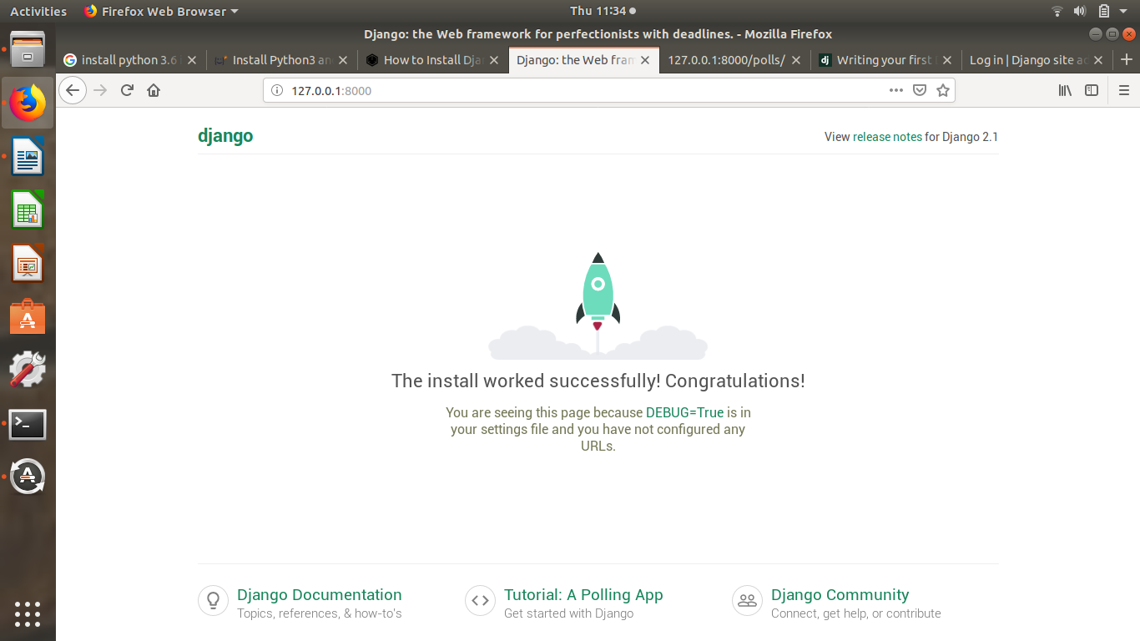
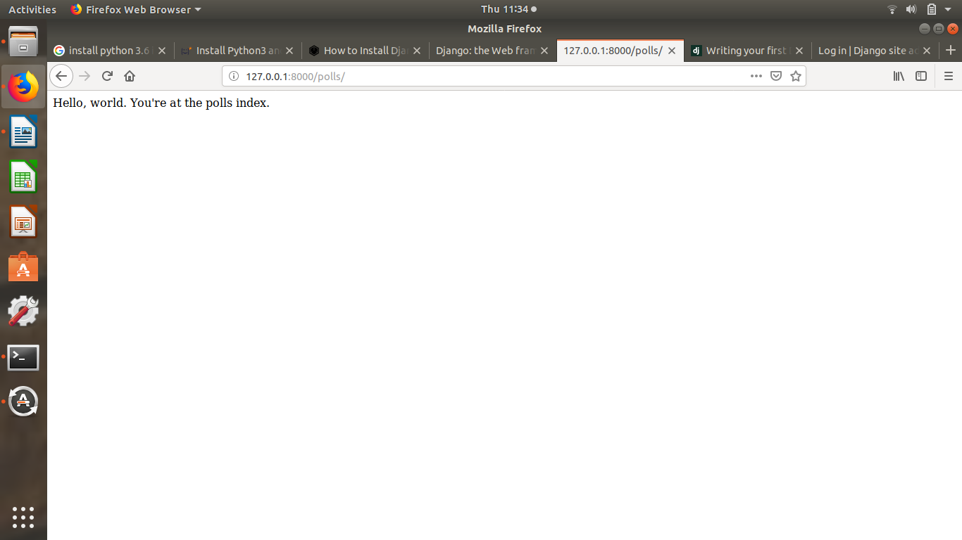
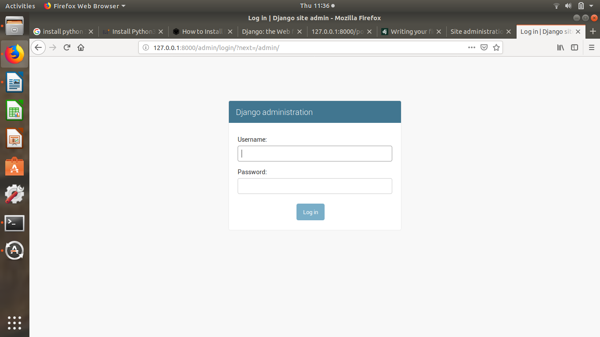
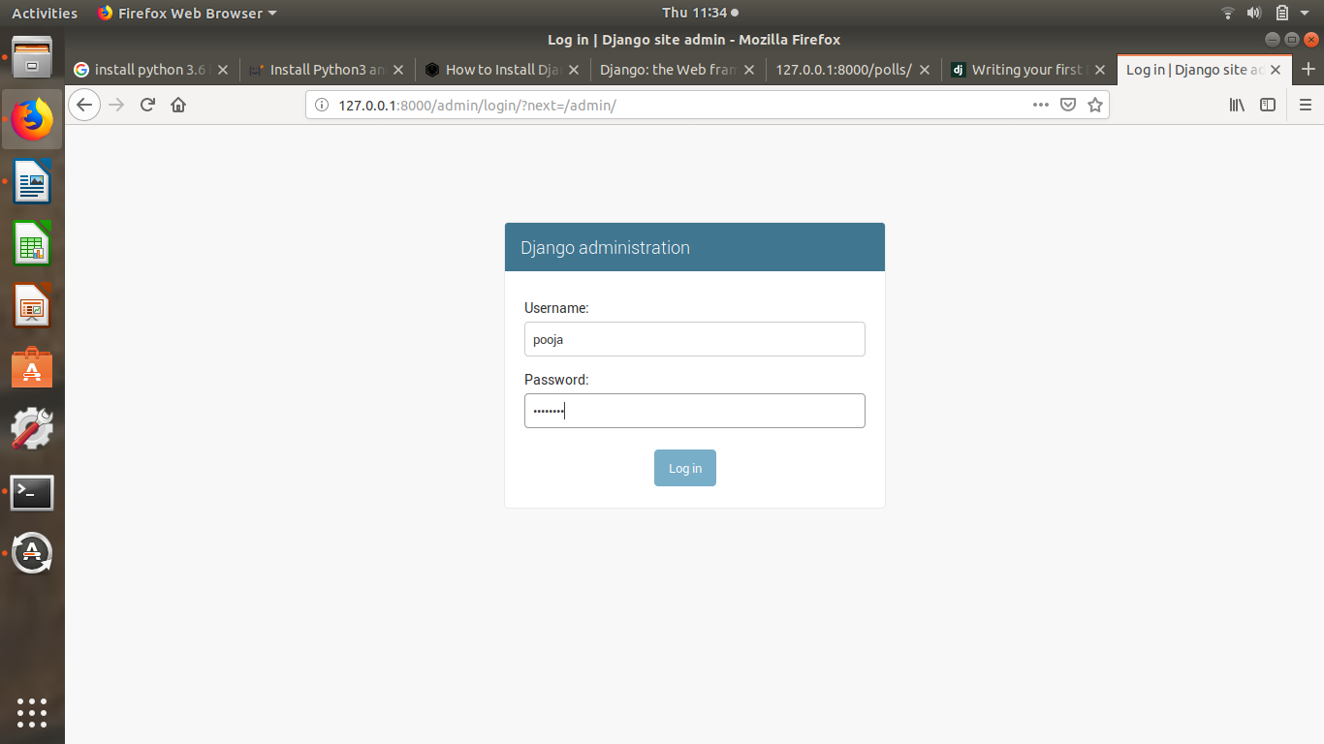
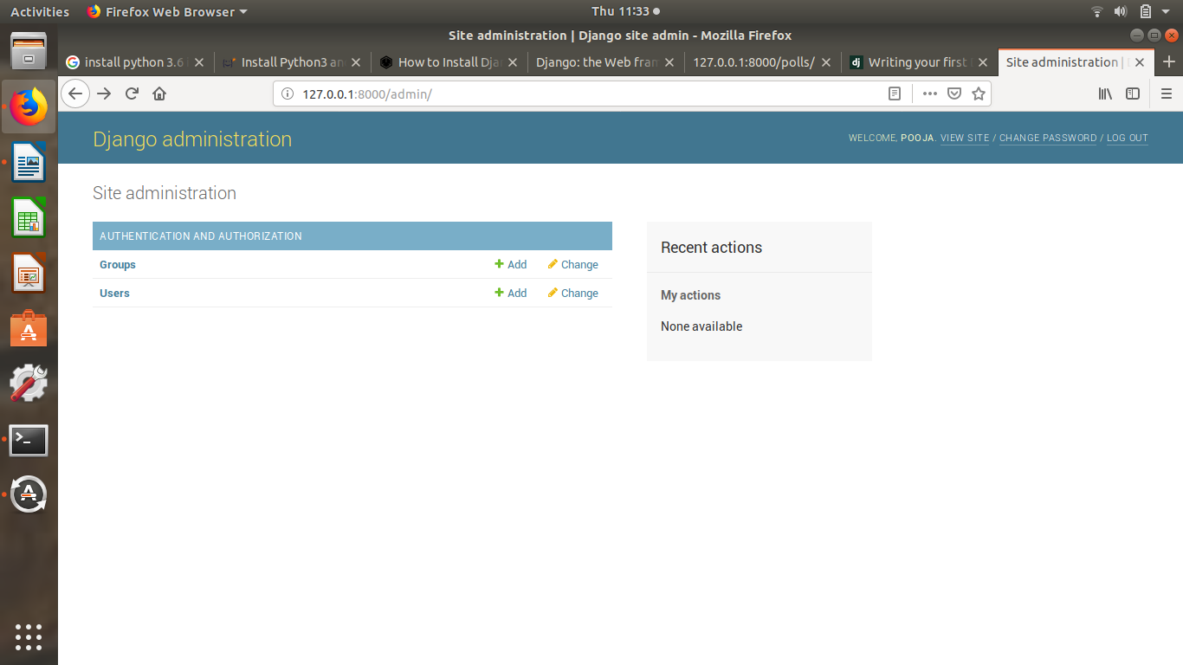
End of Polls Assignment.

